KKJ Týn nad Vltavou, z.s., Solní 422, 375 01 Týn nad Vltavou
Email: elbh@iol.cz, www.canoemar.cz

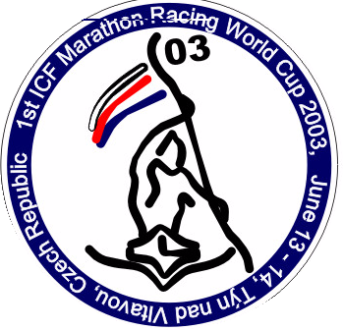
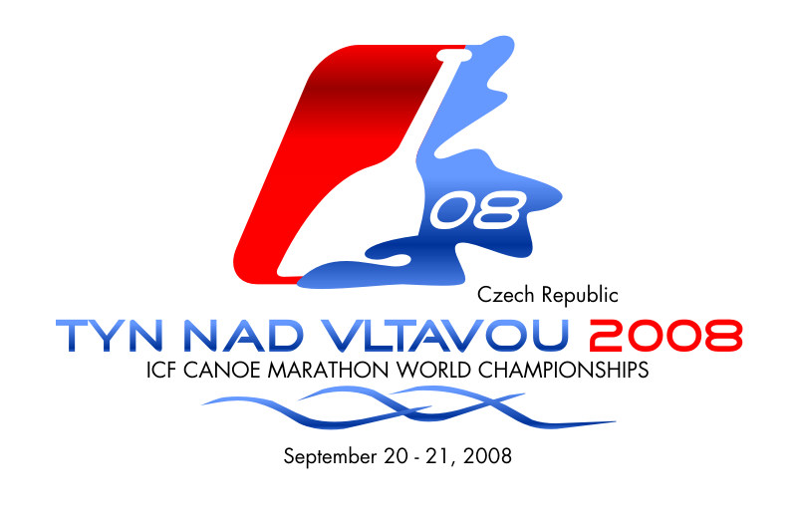
In Tyn nad Vltavou on 29. 2. 2016

Proposition

The name of competition: Vltavotynske water paddlers celebrations 2016
ELBH, Havlickova 35, Tyn nad Vltavou 375 01, Czech Republic
phone: +420 608 166500, +420 602 363947, fax:+420 385 721245 email: info@canoemar.cz, www.canoemar.cz
Date: 3. 9. 2016
Organizer: KKJ Tyn nad Vltavou, z.s.
Course: The Vltava river, The Luznice river - calm water

Timetable:
Presentation of paddleboards, possibillity of trying 9:30 – 11:00 am
Between the bridges - first part 9:45 – 11:30 am
Speed K-1, C-1 Men Senior, Men junior 9:45 – 9:55 am
Speed K-1, C-1 Women, Women junior 9:55 – 10:05 am
Spped K-1, C-1 Men (00-01), Men (02-03) 10:05 – 10:15 am
Speed K-1, C-1 Women (00-01), Women (02-03) 10:15 – 10:25 am
Travel C-2 up to 12 years 10:25 – 10:40 am
Sea and downriver boats 10:40 – 10:55 am
Paddleboard 11:00 – 11:15 am

The medal ceremony of all categories "Between the bridges" will be immediately after the finish of race on a pontoon under the finish tower.
Training of canoepolo 10:00 am – 12:00 pm
Start of „Vltavotynsky LAKER maraton“ 12:00 pm
Between the bridges - second part 12:15 pm
Speed K-1, C-1 children (up to 04) 12:15 – 12:30 pm
Travel C-2, C-2mix, over 18 years 10:25 – 10:40 am
Travel C-2 up to 18 years 12:45 – 1:00 pm
The medal ceremony of all categories of "Between the bridges" will be immediately after the finish of race on a pontoon near the finish tower .
Match of canoepolo 1:00 – 6:00 pm
Medal ceremony of Vltavotynsky LAKER maraton 4:00 – 5:30 pm
Medal ceremony of canoepolo 6:00 – 6:30 pm
After Party 6:30 - 11: 00 pm

Proposition of Vltavotynsky LAKER maraton
Date: 3. 9. 2016
Organizer: KKJ Tyn nad Vltavou, z.s.
Venue: Tyn nad Vltavou, Canoe stadium Valcha, the Vltava river, the Luznice river - calm water
Start: Mass start at 12:00 pm, Canoe stadium Valcha
Finish: Canoe stadium Vlacha, at the finish will be refreshment (tea, water, fruit, cakes)
Course: Start of race will be downstream the Vltava river, further confluence, portage on the Luznice river - portage Canoe stadium Valcha - turning point. Info is on maps.

Distance for travel C-2 1x 12,7km (1 lap)
Distance for other 2x 12,7km = 25,4km (2 laps)

Portage - Confluence: A nature portage 100m long will be placed near the right bank of the Luznice river. There will be no pontoon. The portage area will be clearly shown by barriers and marked with red and yellow marks at the disembarkation and embarkation places. Disembarkation place will be near the left bank of billabong of Vltava river. A portage is required for all competitors. On the correct course of supervising referee.

Portage - Canoe stadium Valcha: A portage 100m long will be placed near the left bank of the Vltava river under the finish tower. The pontoon will be used for getting out. The stone bank will be used for getting in.The portage area will be clearly shown by barriers and marked with red and yellow marks at the disembarkation and embarkation places. In the portage area will be refreshment (tea, water, fruit, cakes).

Turning points will be marked with red buoys.

Start no.: Each competitor gets a start number in the accredation. Start number must be throughout the race conspicuously placed on the jersey.
Equipment: Competitors start at their own risk.
Competitors up to 18 years must show parental consent.
During the race, it is recommended life jacket. Competitors start at their own risk. .

Parking: Zizkova street, area elemetary school Mala Strana, area shipyard Solni street, parking Pod Kostelem - All car parks are near the start and finish line.
Start fee: Start fee must be paid at accreditation in only cash - 200 Czech crowns/person.
Registration forms: Registration forms should be submitted on the day the race in 11:00 am.
Accredition will take place in finish tower from 7:30 to 11:00 am.
Debate: 11:00 – 11:30 am near finish tower

Categories:
Speed boats K-1 Men Junior
K-1 Men
K-1 Men Masters
C-1 Men Junior
C-1 Men
C-1 Men Masters
K-1 Women Junior
K-1 Women
K-1 Women Masters
K-2 mix
Sea kayak K-1 Men
K-2 mix
Downriver kayak K-1 Men Junior
K-1 Men
K-1 Men Masters
K-1 Women Junior
K-1 Women
K-1 Women Masters
Stand Up Paddle (SUP) Paddleboard
Men
Women
(for Division, stocks maximum 14“ indiscriminately construction)
Travel boats C-2 Men
C-2 Women
C-2 mix

Prices: The first three competitors in the category will receive a medal.
Each competitor will receive a diploma. (Diplomas can be collected after finishing the race in the race office.)
Price money 1. competitor in overall ranking 1,500 Czech crowns
2. competitor in overall ranking 1,000 Czech crowns
3. competitor in overall ranking 500 Czech crowns
The first competitor in overall ranking wins kayak K-1 LAKER by Zastera Composites http://www.zastera.cz/en/

Medal ceremony: 4:00 – 5:30 pm There Canoe stadium Valcha

Next informations:
- life jacket are recommended
- It is allowed to use any pumps (foot and electric)
- !!The time limit for the finish is 5:30 pm
- Competitors start at their own risk. They must be good swimmers.
- The organizer reserves the right to change the rules.

Proposition of "Between the bridges"
Date: 3. 9. 2016
Organizer: KKJ Týn nad Vltavou, z.s.
Course: Týn nad Vltavou, Canoe stadium Valcha, the Vltava river
Start: Starts of races will be by individual categories. The first star will be at 9:45 am between the bridges near the finish tower - Canoe stadium Valcha.
Finish: Canoe stadium Valcha
Course: Start of race will be downstream the Vltava river. Turnpoint is around a pillar of the iron bridge. Further - portage - turnpoint around a pillar of the concrete bridge - finish. The lenght of the race is 750 meters, including the portage (100 meters).

Portage - Canoe stadium Valcha: A portage 100m long will be placed near the left bank of the Vltava river under the finish tower. The pontoon will be used for getting out. The stone bank will be used for getting in.The portage area will be clearly shown by barriers and marked with red and yellow marks at the disembarkation and embarkation places. In the portage area will be refreshment (tea, water, fruit, cakes).

Star no.: Each competitor gets a start number in the accredation. Start number must be throughout the race conspicuously placed on the jersey
Equipment: Competitors up to 12 years must have life jacket. (Life jackets can be rented on place.)
Competitors start at their own risk.

Parking: Zizkova street, area elemetary school Mala Strana, area shipyard Solni street, parking Pod Kostelem - All car parks are near the start and finish line.
Start fee: Start fee must be paid at accreditation in only cash - 50 Czech crowns/person. Children (up to 04) 20 Czech crowns/person.
Registration forms: Registration forms should be submitted on the day the race in 9:00 am.
Accredition will take place in finish tower from 7:30 to 9:15 am.
Debate: 9:15 – 9:30 am near finish tower

Categories:
Speed K-1, C-1 Men
K-1, C-1 Men Junior
K-1, C-1 Women
K-1, C-1 Woman Junior
K-1, C-1 Men (00-01)
K-1, C-1 Men (02-03)
K-1, C-1 Women (00-01)
K-1, C-1 Women (02-03)
K-1, C-1 Men Child (up to 04)
K-1 Women Child (up to 04)
Travel C-2 to 12 years
Travel C-2, C-2 mix, over 18 years
Travel C-2 to 18 years
Sea kayaks
Downriver kayaks Men
Women
Paddleboard Men
Women
Medal ceremony will each category separately.

Prices: The first three competitors in the category will receive a medal.
Each competitor will receive a diploma. (Diplomas can be collected after finishing the race in the race office.)

The medal ceremony will be immediately after the finish of race near the finish tower.

Next informations:
- life jacket are recommended,
- Competitors up to 12 years must have life jackets.
- Competitors start at their own risk. They must be good swimmers.
- The organizer reserves the right to change the rules.

Proposition of CANOEPOLOPROPOZICE TURNAJ KANOEPOLO
Date: 3. 9. 2016
Organizer: KKJ Týn nad Vltavou, z.s.
Course: Týn nad Vltavou, Canoe stadium Valcha, the Vltava river
Training: 10:00 am – 12:00 pm
Meeting, explaining the rules 12:00 – 12:45 pm
Tournament of canoepolo: 1:00 – 6:00 pm
The system of the tournament will be specified during the meeting by number of teams:
Up to 6 teams: All teams play each other once .
7 - 10 teams: Teams will be divided into two groups. The first and second team from the group will play single- elimination tournament. The group winners will play for first andsecond place. The losers will play for third and fourth place.
11 - 16 teams: single-elimination tournament
Course description:
Playing area will be delimited at calm river. Boundary of the playing area will be by pontoon.Equipment: The organizer will provide required equipment for the tournament (kayaks, paddles, life jackets, helmets).
Competitors start at their own risk.
Parking: Zizkova street, area elemetary school Mala Strana, area shipyard Solni street, parking Pod Kostelem - All car parks are near the start and finish line.
Start fee: 500 Czech crowns/team
Registration forms:
Registration forms should be submitted on the day the race in 11:00 am.
Categories: without difference age and gentle
Prices: The first three teams will receive a medals and a diplomas.

CULTURAL PROGRAM
Musical accompaniment – Family Bluegrass Band Luňáčci,, Vandrband, Ko Ko dák, Klídek, Hladomor,
Bouncy Castle by HELUZ CompanyBooth of boats, paddles, sportswear and equipment
Presentation of paddleboarding - There will be the opportunity to try a new sport.
There will be a possibility to rent equipment for testing canoepolo.
After Party.

If you have any questions please write to "Jiří Kobera" kobera@atelierkobera.cz

